Practical - 7
Practical Title: PHP Form Processing with Server-Side Validation and CSV/JSON File Storage
Problem Definition: Process submitted registration/contact form data using PHP. Validate and sanitize inputs on the server side and store records in CSV or JSON file format. Display success/error messages.

Theory :
1. Is the form submitted using POST?

Yes, the form uses the POST method to securely send form data to the PHP server for processing.

2. Are inputs validated and sanitized server side?

Yes, user inputs are validated and sanitized on the server side using PHP before being stored.

3. Is file writing handled safely?

Yes, file writing is handled safely by opening the CSV file in append mode, writing data using fputcsv(), and closing the file after writing.

4. Are success and error responses displayed clearly?

Yes, clear success and error messages are displayed to inform the user about the result of the form submission.

Data:
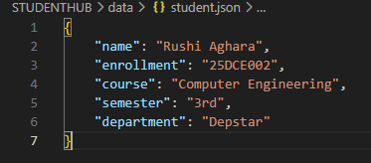
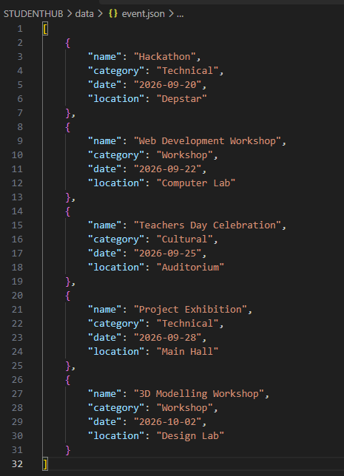

Implementation/ Output/Result
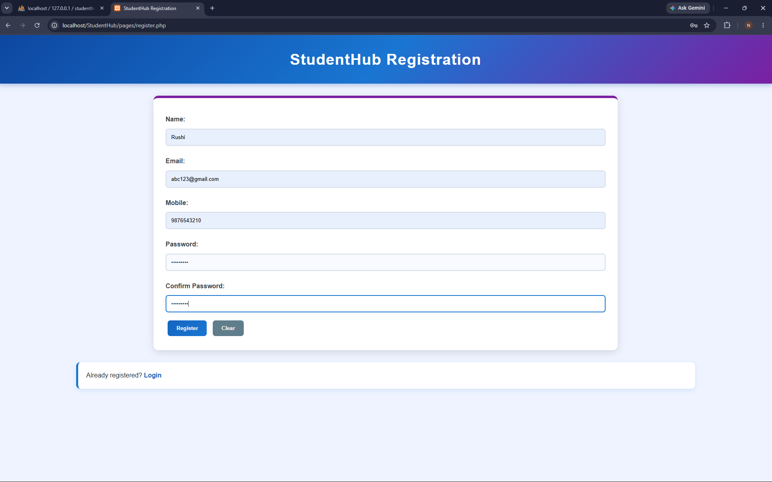
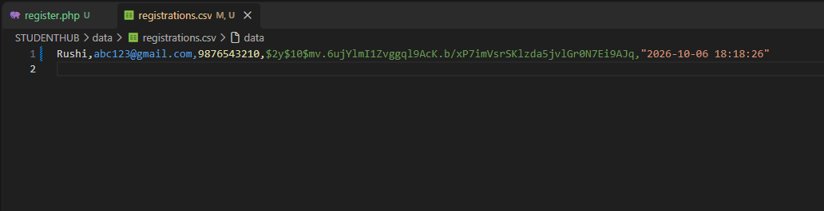

GitHub Repository Link:

https://github.com/rushiaghara25/StudentHub-Portal-2.git

Learning Outcomes:

Understand PHP form processing using the POST method.

Implement server-side validation and sanitization of user inputs.

Store form data safely in CSV or JSON files using PHP.

Handle file operations for storing submitted records.

Display clear success and error messages to users.

Develop basic backend form-processing skills using PHP and XAMPP.

Faculty Remarks: (Keep this blank for faculty)

